Insert School Logo

Semester Two Examination 2019 Question/Answer Booklet

MATHEMATICS
METHODS UNITS 1 & 2

Section Two:
Calculator-assumed

Student Name: _____________________________________

Teacher’s Name: _____________________________________

Time allowed for this section
Reading time before commencing work: ten minutes
Working time for paper: one hundred minutes

Material required/recommended for this section

To be provided by the supervisor
This Question/Answer booklet
Formula Sheet (retained from Section One)

To be provided by the candidate
Standard items: pens (blue/black preferred), pencils (including coloured), sharpener, correction tape/fluid, erasers, ruler, highlighters

Special Items: drawing instruments, templates, notes on two unfolded sheets of A4 paper, and up to three calculators approved for use in the WACE examinations.

Important note to candidates
No other items may be taken into the examination room. It is your responsibility to ensure that you do not have any unauthorised notes or other items of a non-personal nature in the examination room. If you have any unauthorised material with you, hand it to the supervisor before reading any further.

Structure of this paper

 | Number of questions available | Number of questions to be attempted | Suggested working time (minutes) | Marks available | %
Section One  Calculator—free | 9 | 9 | 50 | 52 | 35
Section Two  Calculator—assumed | 14 | 14 | 100 | 98 | 65
 |  |  |  | 150 | 100

Instructions to candidates

- The rules for the conduct of Western Australian external examinations are detailed in the Year 12 Information Handbook 2019. Sitting this examination implies that you agree to abide by these rules.

- Answer the questions according to the following instructions.

Section Two: Write answers in this Question/Answer Booklet. Answer all questions.

Show all your working clearly. Your working should be in sufficient detail to allow your
answers to be checked readily and for marks to be awarded for reasoning. Incorrect
answers given without supporting reasoning cannot be allocated any marks. For any
question or part question worth more than two marks, valid working or justification is required to receive full marks. If you repeat an answer to any question, ensure that you cancel the answer you do not wish to have marked.

It is recommended that you do not use pencil, except in diagrams.

- You must be careful to confine your responses to the specific questions asked and to follow any instructions that are specific to a particular question.

- Spare pages are included at the end of this booklet. They can be used for planning your responses and/or as additional space if required to continue an answer.
- Planning: If you use the spare pages for planning, indicate this clearly at the top of the page.
- Continuing an answer: If you need to use the space to continue an answer, indicate in the original answer space where the answer is continued, i.e. give the page number. Fill in the number of the question that you are continuing to answer at the top of the page.

- The Formula Sheet is not handed in with your Question/Answer Booklet.

Section Two: Calculator–assumed 65% (98 marks)

This section has fourteen (14) questions. Attempt all questions. Write your answers in the spaces provided.

Spare pages are included at the end of this booklet. They can be used for planning your responses and/or as additional space if required to continue an answer.

- Planning: If you use the spare pages for planning, indicate this clearly at the top of the page.
- Continuing an answer: If you need to use the space to continue an answer, indicate in the
original answer space where the answer is continued, i.e. give the page number. Fill in the
number of the question(s) that you are continuing to answer at the top of the page.

Working time: 100 minutes

Question 10 (7 marks)

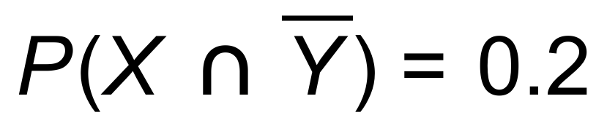 , 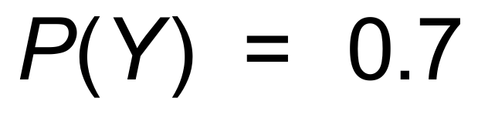 and 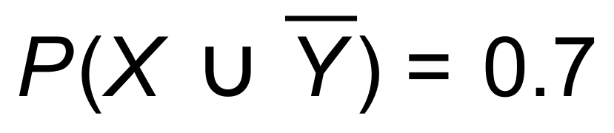

(a) Complete the Venn diagram using the information given. (2 marks)
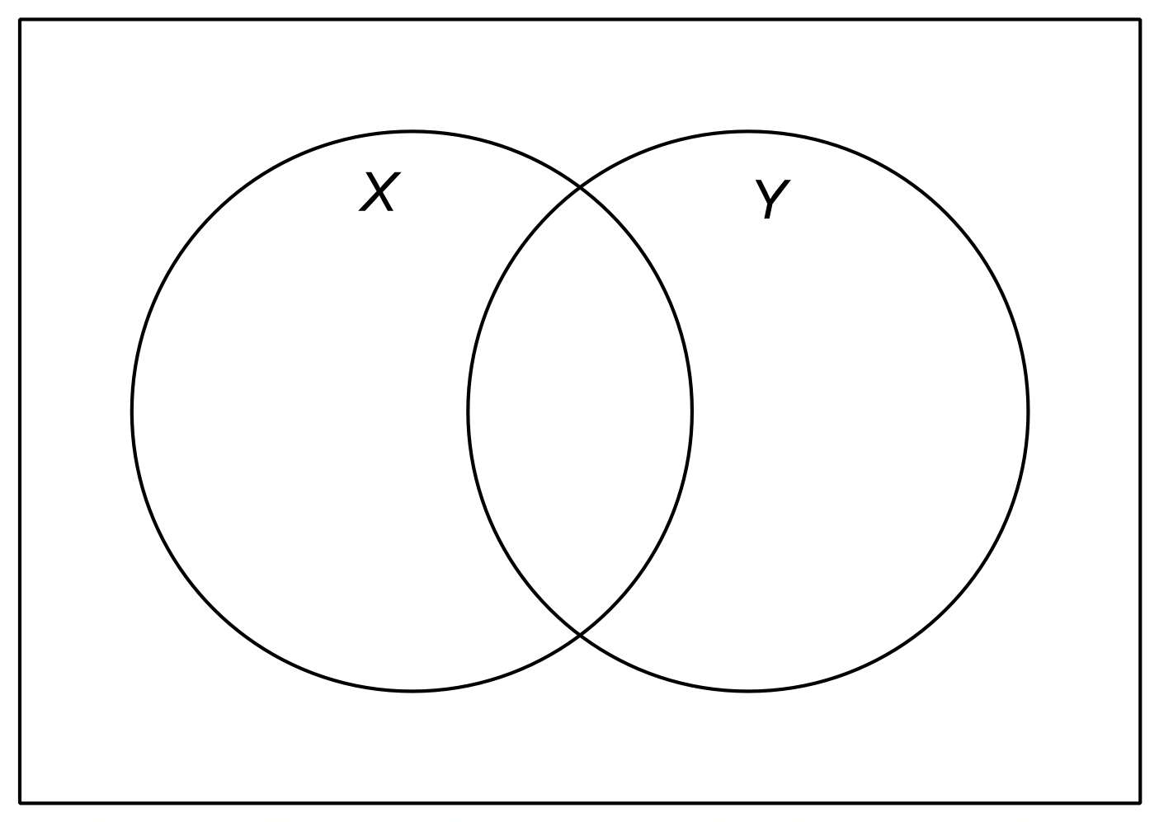

(b) Determine:

(i) 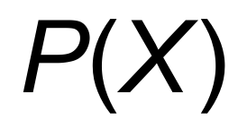 (1 mark)

(ii) 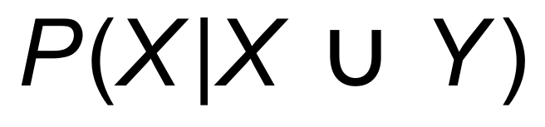 (2 marks)

(c) Show mathematically why X and Y are not independent events. (2 marks)

Question 11 (6 marks)

A geometric sequence is given by a, ar, ar², …

(a) If the sequence has a sum to infinity, what can be determined about the value of r ?
(1 mark)

The second term of the sequence is 20 and the sum to infinity is 125.

(b) Determine a and r for the sequence. Show your reasoning. (3 marks)

(c) Calculate the sum of the first ten terms of the sequence.
Round your answers to four significant digits. (2 marks)

Question 12 (10 marks)

The graph of y = f(x) is drawn below.
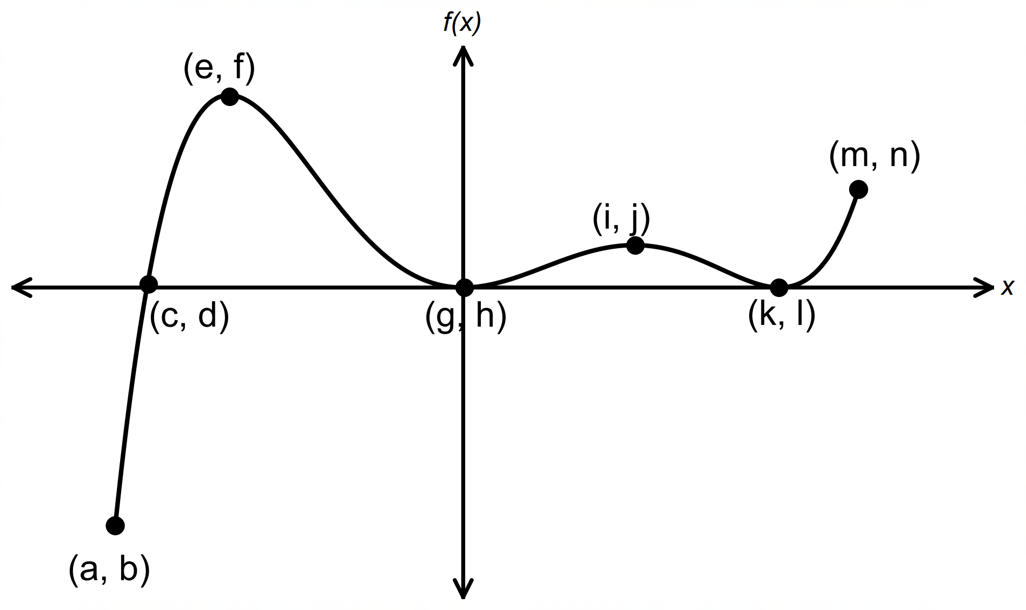

Use the variables a, b, …., n in answering the following questions.

(a) State the co−ordinates of:

(i) the roots of f (x) = 0. (2 marks)

(ii) any local maxima. (2 marks)

(iii) any global minimum. (1 mark)

(b) State the values of x for which the function is increasing. (2 marks)

(c) State the values of x for which f ′(x) < 0. (2 marks)

(d) If the equation of the function is y = x² (x − 2) ² (x + 2), state the value of k. (1 mark)

Question 13 (10 marks)

The population of rats in a town is given as 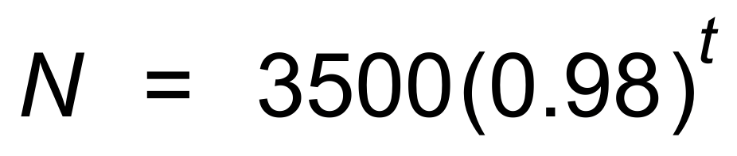, where N is the number of rats at any time, t months, after January 1st 2019.

(a) The number of rats in the town is decreasing. Explain how the relationship above
shows this fact. (1 mark)

(b) Calculate the number of rats at the beginning of January 2020.
Show your reasoning. (2 marks)

(c) When, to the nearest month, will the number of rats first drop below 2000.
Show some working. (2 marks)

Another town has 2000 rats on January 1st 2019, and 3200 rats on January 1st 2020.
The relationship between the number of rats, R, at any time t months after January 1st 2019
is known to be exponential.

(d) Determine the exponential relationship between R and t. (2 marks)

(e) During which month will the number of rats be equal in both towns. Show your reasoning.
(3 marks)

Question 14 (6 marks)

The amount of water (W), in litres, flowing into a water tank over a four minute period is
modelled by the function , where t is the number of
minutes after t = 0.

(a) How many litres flow into the tank initially? (1 mark)

(b) Use Calculus to determine, during which minute the amount of water flowing into
the water tank is a minimum. (3 marks)

(c) Use your calculator, or otherwise, to determine:

(i) the minimum amount of water flowing into the water tank during the four minutes.
(1 mark)

(ii) the maximum amount of water flowing into the water tank during the four minutes.
(1 mark)

Question 15 (10 marks)

A particle undergoing rectilinear motion has its displacement, in metres, at any time t, seconds,
given by the equation 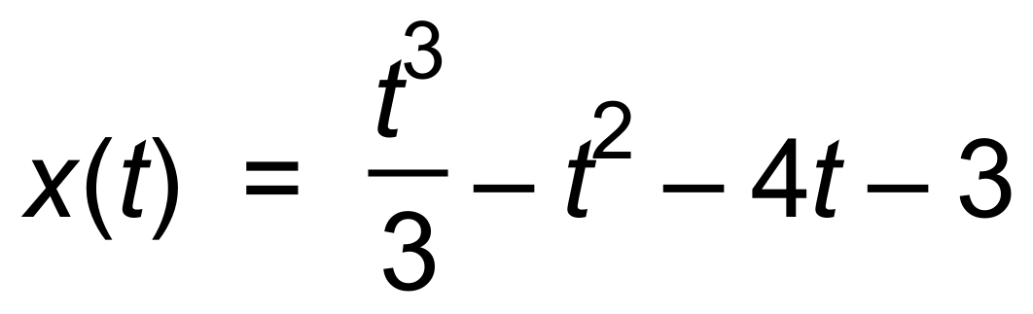.

(a) Determine:

(i) the displacement of the particle at 3 seconds. (1 mark)

(ii) the velocity of the particle at any time t seconds. (2 marks)

(b) Calculate the speed of the particle at 3 seconds. (2 marks)

(c) Find when, correct to one decimal place, the particle is at rest. (2 marks)

(d) Calculate the total distance travelled by the particle during the first five seconds. (3 marks)

Question 16 (7 marks)

A function is defined by the equation 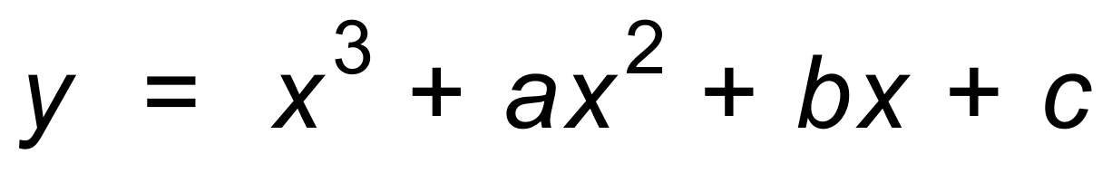.
The y−intercept is 5, and a horizontal point of inflection exists at (−2, −3).

(a) Determine the value of c. (1 mark)

(b) Determine the values of a and b. (4 marks)

(c) Hence, or otherwise determine the root(s) of the function.
Round to three significant figures, where necessary. (2 marks)

Question 17 (6 marks)

The gradient of a function at any point (x, y) on the curve is given by 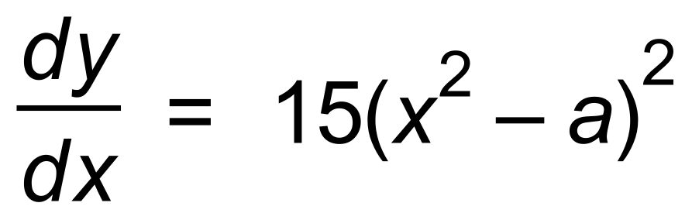.
The graph passes through the origin.

(a) Show that the primitive function is given by 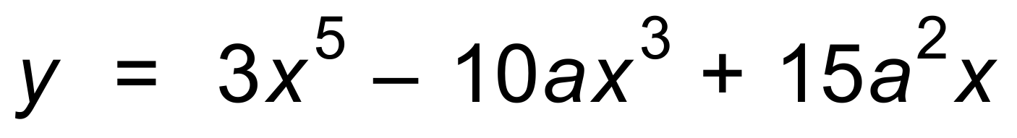. (3 marks)

The function has two stationary points.

(b) Show that a > 0. (3 marks)

Question 18 (7 marks)

John is trying to get fit for Summer.
In the morning John has a 90% chance of exercising before heading to school. If John exercises before school he has a 10% chance of being late to class.
If John doesn’t exercise before school he has a 15% chance of being late to class.

(a) Complete the tree diagram below to show John’s pattern in the morning.
Let E be the event “John exercises in the morning”, and
L be the event “John is late to class”. (2 marks)

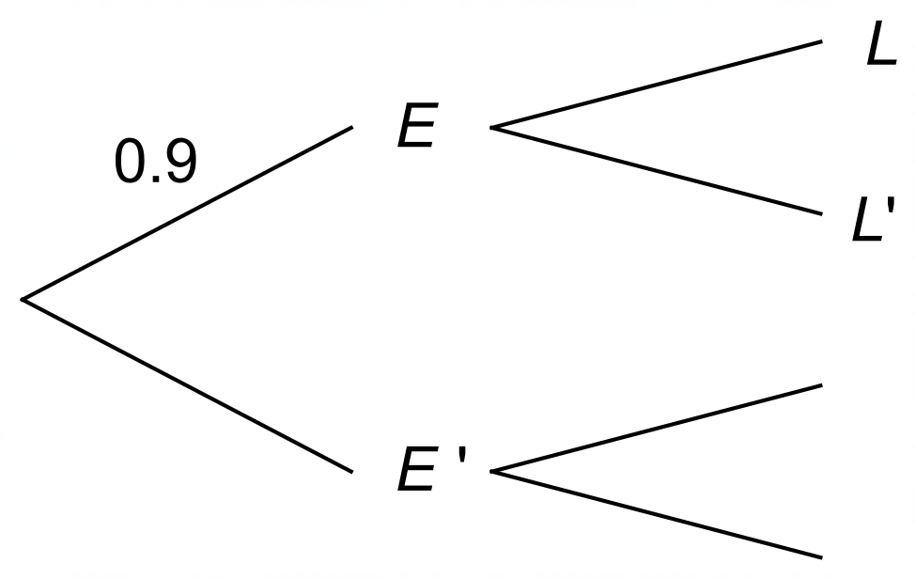

(b) Determine the probability that John:

(i) is late to class. (2 marks)

(ii) is not late to class, if he does not exercise in the morning. (1 mark)

(iii) exercised in the morning, given he was late to class. (2 marks)

Question 19 (6 marks)

The graphs of are drawn below.

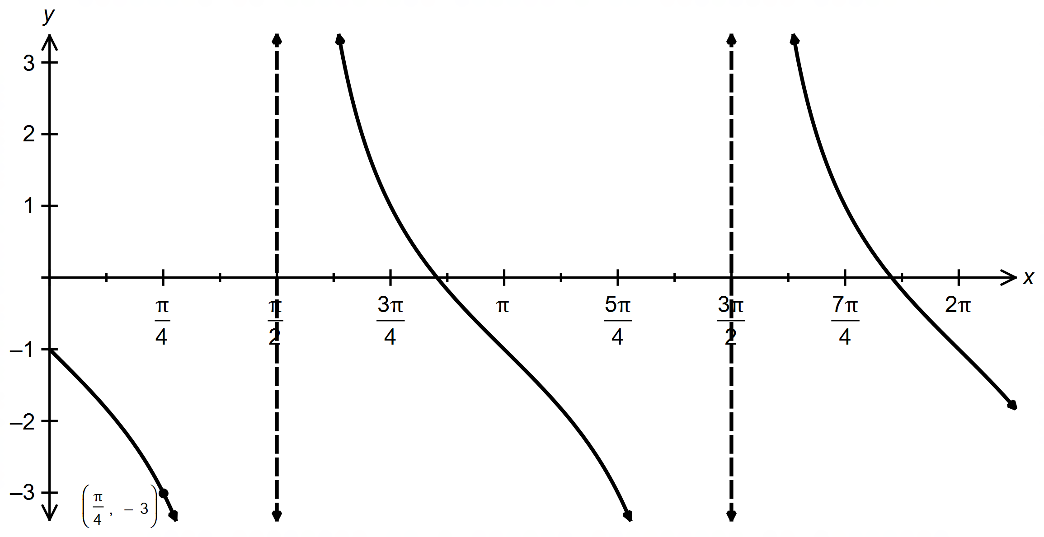

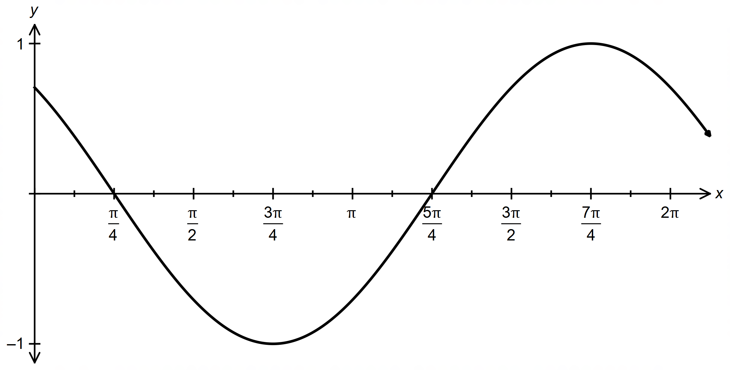

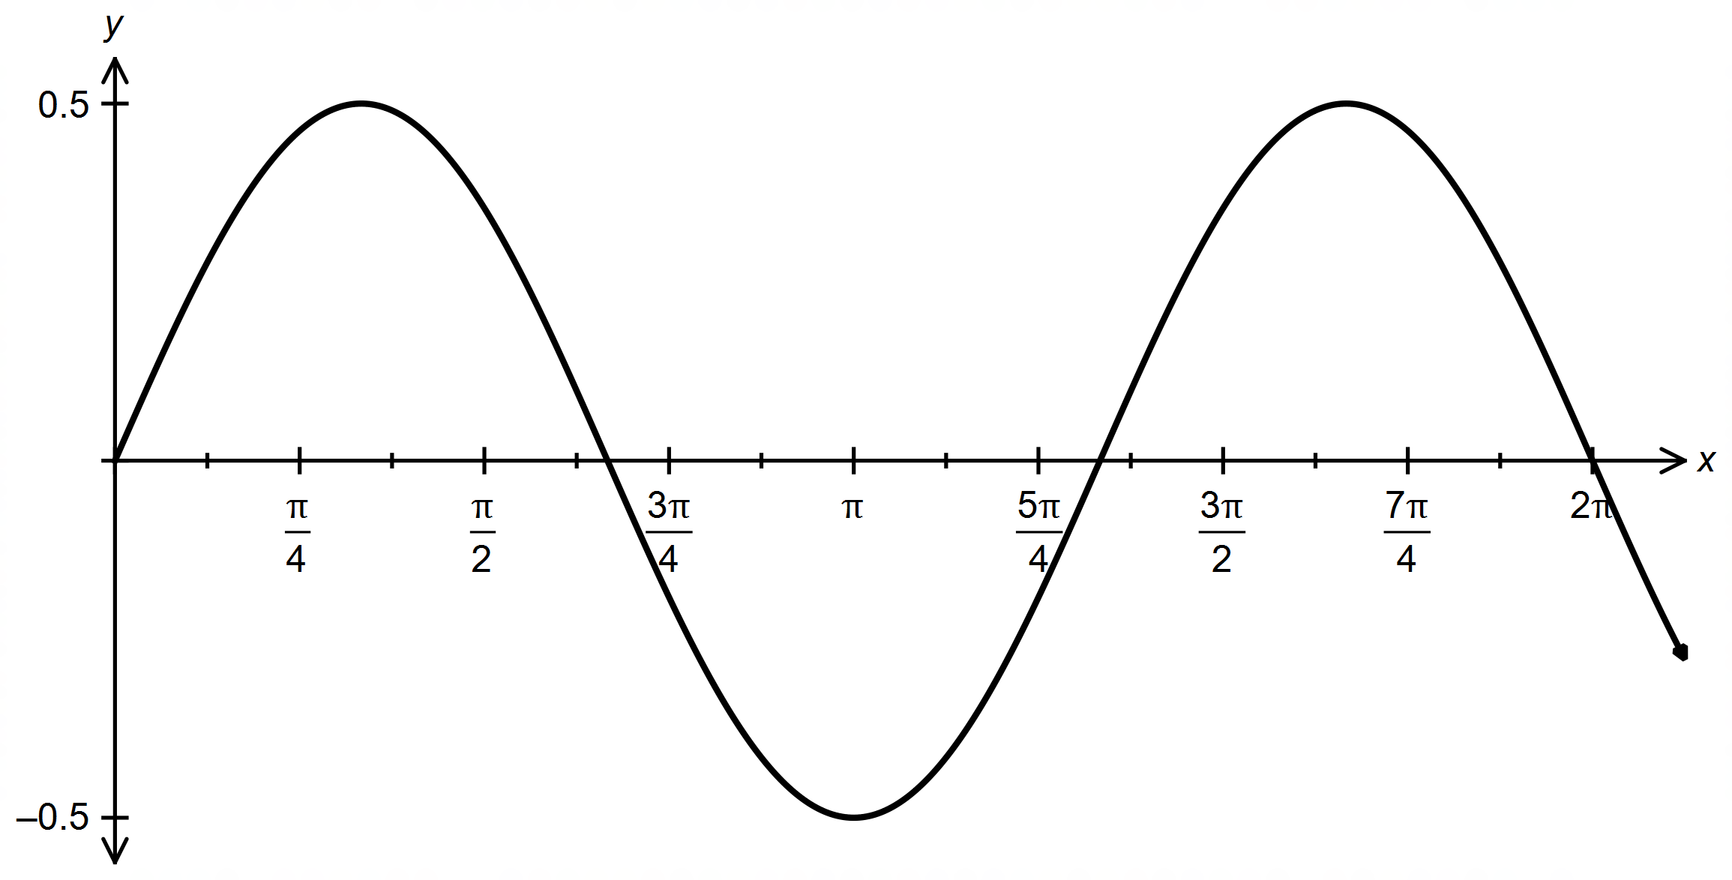

Determine the values of a, b, c, d and e. (6 marks)

Question 20 (6 marks)

Consider the following graph of the function y = f (x).
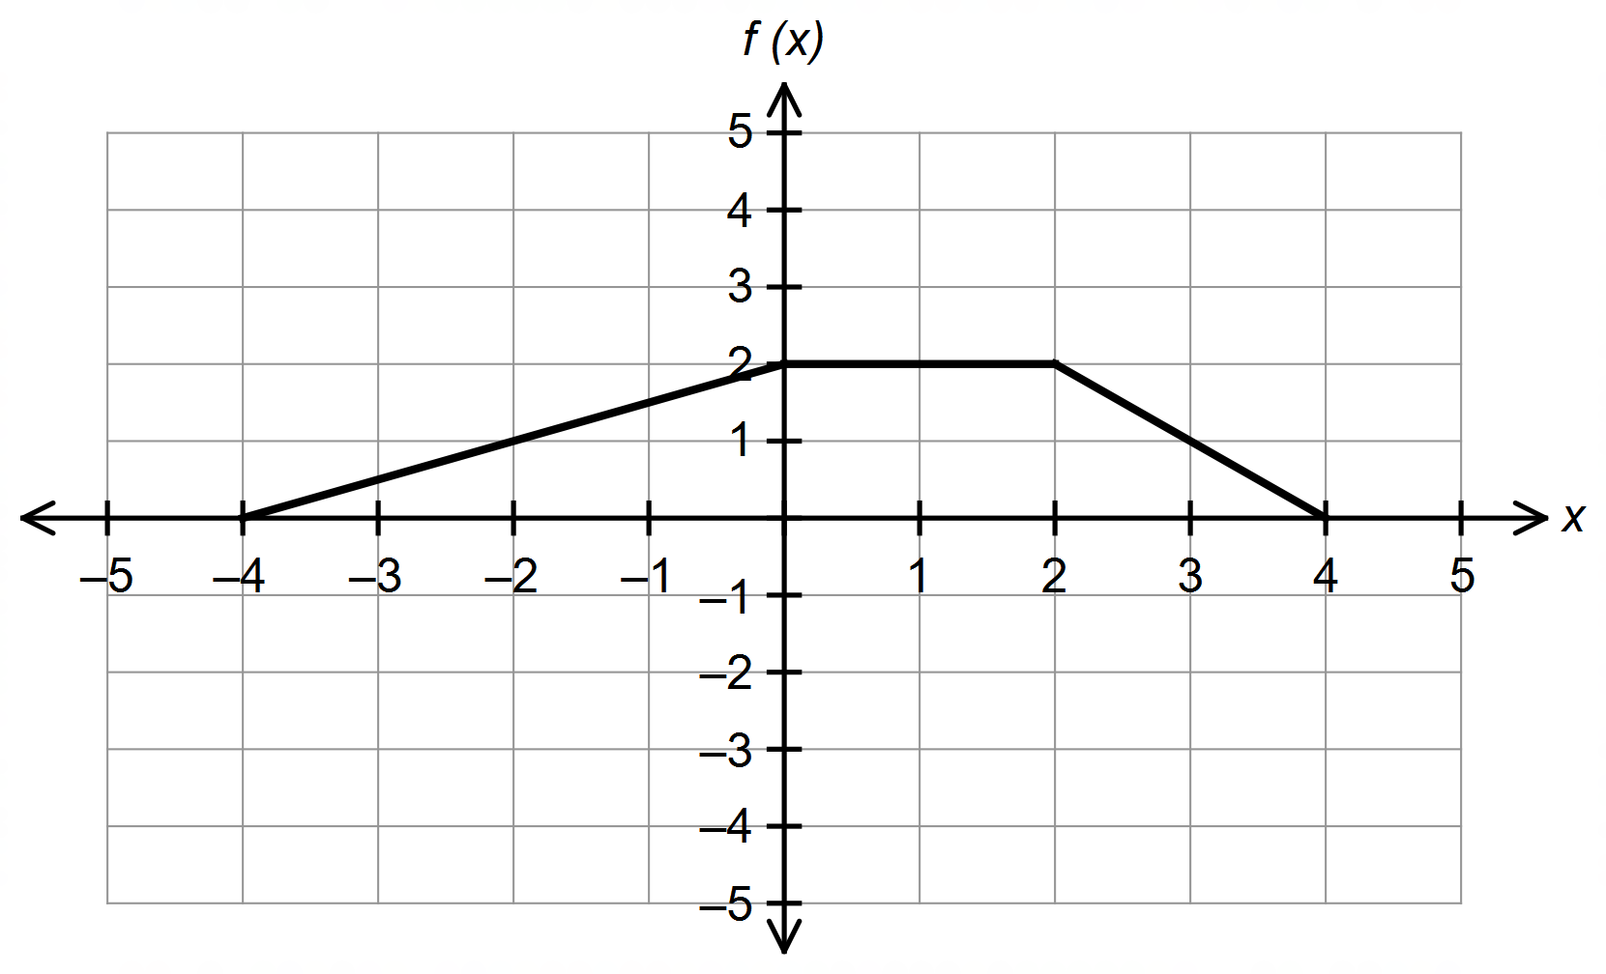

(a) Solve:

(i) f (x) = 0 (1 mark)

(ii) f (0) (1 mark)

(b) Sketch on the same axes.

(i) −f (2x) (2 marks)

(ii) 2f (x + 1) (2 marks)

Question 21 (6 marks)

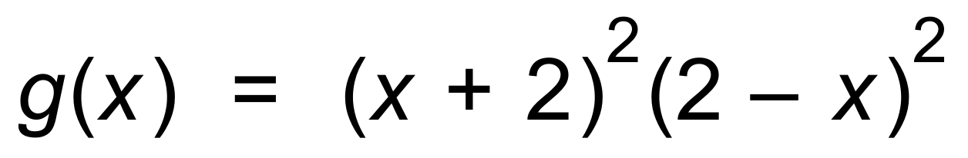

(a) Use Calculus methods to determine the equation of the tangent to the curve
at the point where x = 1. (4 marks)

(b) Use your calculator to determine the other point(s) of intersection of g(x)
and the equation found in (a). Round to three significant figures. (2 marks)

Question 22 (8 marks)

(a) Show that 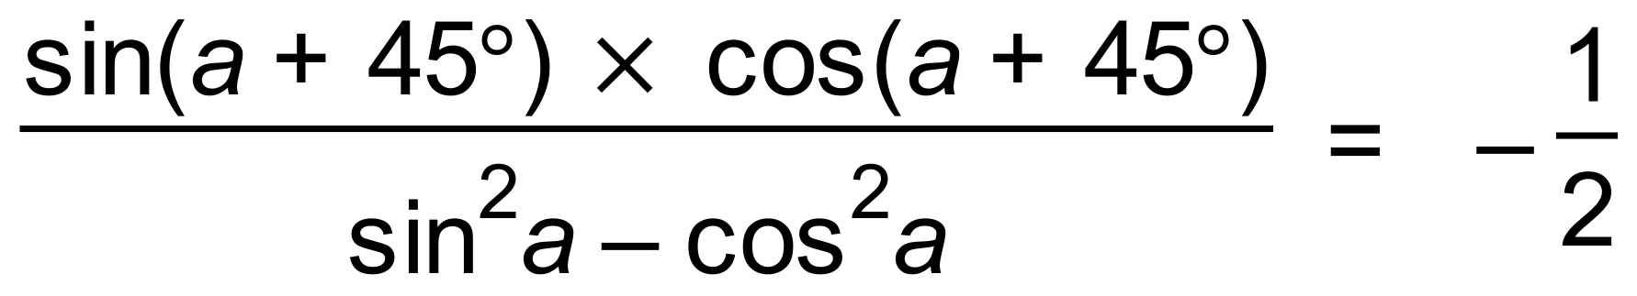. (4 marks)

(b) A navy vessel receives a distress signal from a cruise ship, 100 kilometres away,
at a bearing of S66°E.
A fishing boat receives the same signal at a bearing of N55°E.
If the navy vessel is 180 kilometres from the fishing vessel, determine how far,
to the nearest kilometre, the fishing vessel is from the cruise ship.
Show your working clearly, including a diagram. (4 marks)

Question 23 (3 marks)

Use Pascal’s triangle or otherwise to show that:

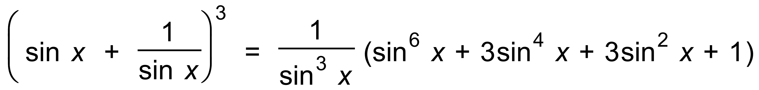 (3 marks)

End of Questions
Additional working space

Question number(s): ……………………

Additional working space

Question number(s): ……………………

